|  |  |
| --- | --- |
|  | **2023** |
|  | **Sharebility Uganda Limited**  WANGANGA JOSHUA |

|  |
| --- |
| **["Baby Animals and Kind Mother Duck"]** |

Once upon a time, in a beautiful meadow, there lived a group of baby animals.

There was a bunny named **Bun Bun**, a chick named **Chickpea**, and a kitten named **Whiskers.**

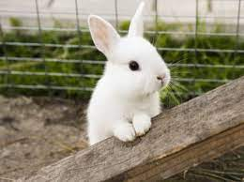

One day, the **baby animals** saw a river. **Whiskers** wanted to play in the water, but **Bun Bun** and **Chickpea** were scared.

They told **Whiskers** to be careful, but she didn't listen.

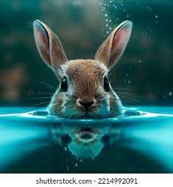

**Whiskers** fell into the river and couldn't swim.

**Bun Bun** and **Chickpea** were worried and didn't know what to do.

Suddenly, a **mother duck** came to help.

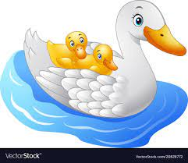

She picked up **Whiskers** and brought her back to the **shore**.

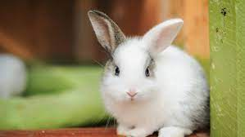 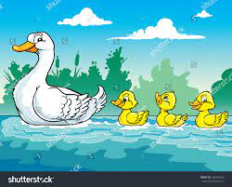

The **baby animals** were very happy and thanked the **mother duck.**

They promised to be careful and always stay safe.

The end.